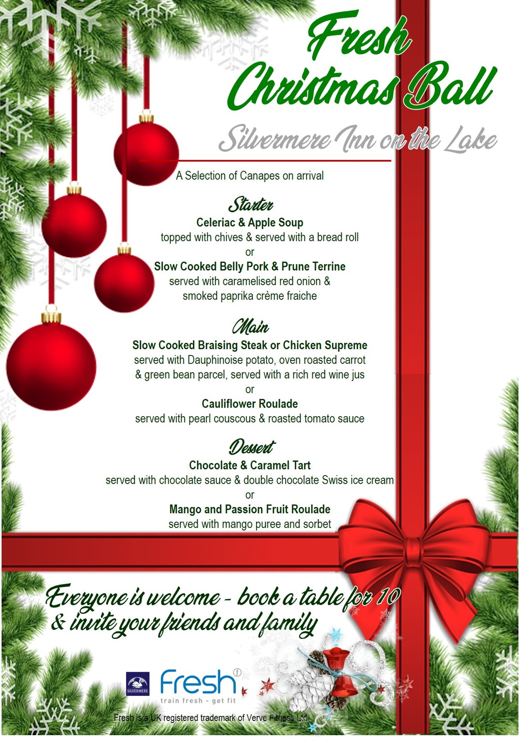

Other bits:
Ticket only event. Tables seat 10.
Please provide your contact details at Reception and a booking form
will be sent via email.

Fresh 2018 Christmas Ball Booking Form, £60 per ticket
Saturday 8th December, 2018, 7pm – 1am
Silvermere Inn on the Lake, Silvermere Golf Complex, Redhill Rd, Cobham KT11 1EF
Dress: Black Tie. Bookings cannot be taken without a deposit or payment in full.
Deposit of £30 per person. Please complete and return to Fresh Reception with your payment

Your Name: |  |  |  | Table Lead Name:
Email:
Tel No: |  |  |  | No in Party:
Payment Details: |  |  | I am paying by □ Cash □ Cheque (to Verve Fitness Ltd) □ Debit Card
For telephone payments by Debit Card, call 01932 225 953 |  |  |  | Date of Telephone Payment:
Deposit paid (£30 per person) |  | £ |  | Payment in full (£60 per person) |  | £
Payment enclosed: |  |  | □ Yes □ No | Total Amount enclosed: |  | £
Full payment due no later than Friday 9th November, 2018

Please choose one starter (A-B), one main (C-E) and one dessert (F-G) from the following,
indicating the letter of your choice next to your name
STARTER | A | Celeriac & Apple Soup topped with chives & served with a bread roll
 | B | Belly Pork & Prune Terrine with caramelised red onion & smoked paprika crème fraiche
MAIN | C | Slow Cooked Braising Steak, dauphinoise potato, roasted carrot & green been parcel, red wine jus
 | D | Chicken Supreme with dauphinoise potato, roasted carrot & green been parcel, red wine jus
 | E | Cauliflower Roulade served with pearl couscous & roasted tomato sauce (v)
DESSERT | F | Chocolate & Caramel Tart served with chocolate sauce & double chocolate Swiss ice cream
 | G | Mango & Passion Fruit Roulade served with mango puree and sorbet

Tables are for Groups of 8-10

 | Name |  | A | B |  | C | D | E |  | F | G
1
2
3
4
5
6
7
8
9
10

