Choose your Lunch Box contents:
1 x sandwich (4 quarters), 2 x sides and 1 x sweet
Sandwich Menu – choose x 1 filling per child: Ham; Cheese; Tuna; Jam; Mixed Selection
(Mixed – if you choose more than one sandwich filling, your order will be equally split with the choices)
Side Menu – choose x 2 sides per child: Veggie Bag (carrots/cucumber/celery sticks); Tortilla Chips;
Seasoned Potato Crisps; Two mini sausage rolls (with ketchup)
Sweet Menu – choose x 1 sweet per child: Fruit Bag (Grapes); Jelly Pot; Yoghurt Pot

Beautifully packaged, our Fresh Kids Lunch Boxes take away all the fuss and worry out your party. Every child gets their own box of food, meaning less waste, plus children take home what’s left in their box – you can use the box as your party bag too!
Lunch Box Menu @ £7.50 per head
Our colourful lunch boxes include:
Selected Food options; Craft Activity; Fresh Kids Fluffy Bag,
Balloon on a Stick, plus Lenny our Mascot Lion joins in the fun!
Choose 1 x sandwich, 2 x sides and 1 x sweet
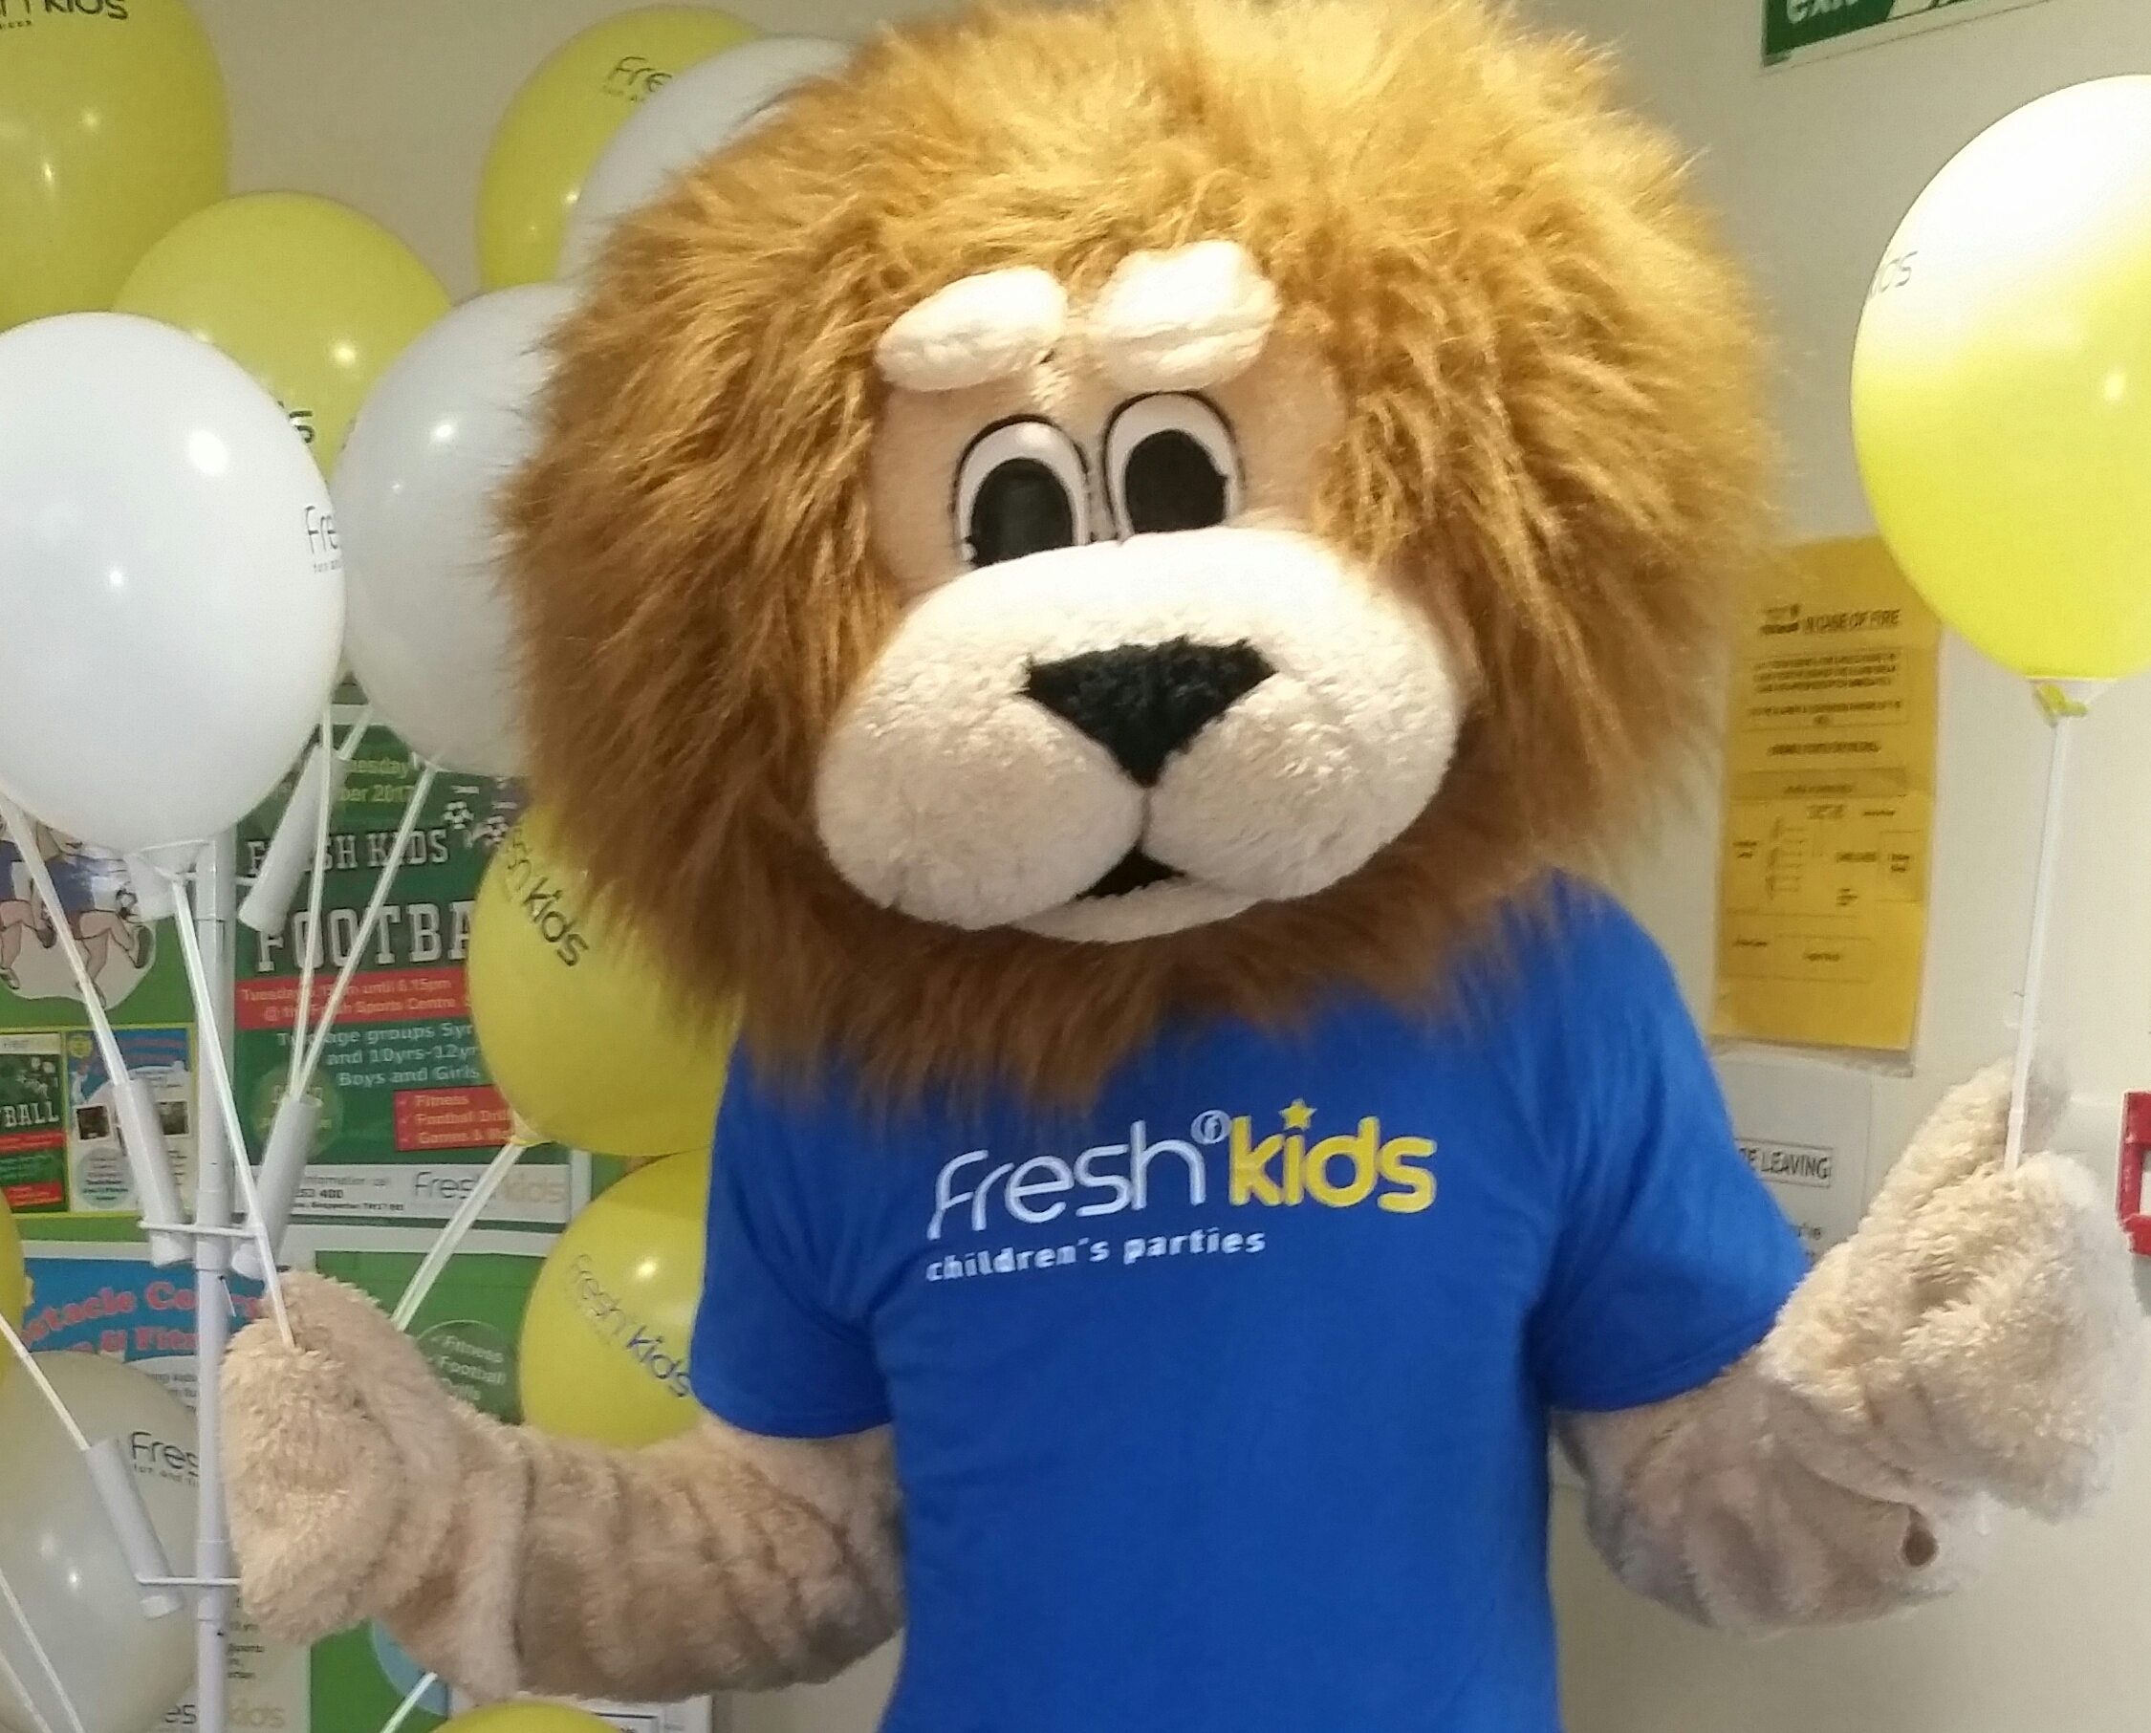
Party Food Order Form

Name: |  |  |  |  |  |  |  |  |  | Date of Party:
Email: |  |  |  |  |  |  |  |  |  | Time of Party:
Lunch Boxes – (includes lunch box, craft activity, Fresh Kids fluffy bug, Balloon on a stick, Lenny the Mascot)
Number of Lunch Boxes required:
1 x Sandwich Menu (√) |  |  |  | 2 x Side Menu (√) |  |  |  |  |  | 1 x Sweet Menu (√)
Ham |  |  |  | Veggie Bag |  |  |  |  |  | Fruit Bag – Grapes
Cheese |  |  |  | Tortilla Chips |  |  |  |  |  | Jelly Pot
Tuna |  |  |  | Potato Crisps |  |  |  |  |  | Yoghurt Pot
Jam |  |  |  | 2 Mini Sausage Rolls
Mixed
Bread (Tick bread type) √ |  | Mixed | White |  | Brown
Food Platters – for Kids and Adults

Freshly made from our award-winning caterers because Party Food is always fun on a Platter. We offer great choices for Children: Sandwiches, Sides and some delicious mini Cake options. Adults get hungry too! Choose a high-quality
sandwich platter with tasty filling options plus our superbly generous cake platters for peckish parents.
Kids Food Platters
Sandwich Platter (serves 10 children) @ £18.00 per platter  – mixed bread and mixed fillings including: ham, cheese, tuna and jam |  |  |  |  |  |  |  |  |  |  | Quantity: |  |  | Total @ £18 per platter:
Crudité Platter (serves 10 children) @ £14.00 per platter  – including assorted crudités with houmous dip |  |  |  |  |  |  |  |  |  |  | Quantity: |  |  | Total @ £14 per platter:
Kids Mini Cake Platter (serves 10) @ £16.00 per platter – including gluten free brownies, choc crispy cake, shortbread, fruit and plain flapjacks and cookies |  |  |  |  |  |  |  |  |  |  | Quantity: |  |  | Total @ £16 per platter:
Adult Food Platters (serves 10) @ £24 per platter
Sandwich Platter (on mixed bread) – select 4 fillings for each platter from: (a) chicken, bacon & sweetcorn (b) chicken tikka (c) cheese & onion (d) egg mayo (e) cheese & pickle (f) ham & cheese  (g) tuna mayo |  |  |  |  |  |  |  |  |  |  |  | Quantity: |  |  | Total @ £24 per platter:
Cake Platter – includes homemade flapjacks, gluten free brownies, cookies, muffins and  cake of the day (lemon drizzle or Victoria sponge) |  |  |  |  |  |  |  |  |  |  |  | Quantity: |  |  | Total @ £24 per platter:
Sandwich Selection  Platter | Platter One: Choose 4 fillings from (a) to (g) above
 | Platter Two: Choose 4 fillings from (a) to (g) above

Party Food Order Summary: | Item | Quantity | Total Cost
 | Lunch Box @ £7.50 per head |  | £ .
 | Kids Sandwich Platter @ £18 each |  | £ .
 | Kids Crudité Platter @ £14 each |  | £ .
 | Kids Mini Cake Platter @ £16 each |  | £ .
 | Adult Sandwich Platter @ £24 each |  | £ .
 | Adult Cake Platter @ £24 each |  | £ .
 | (Minimum order not less than £125) | Total Cost | £ .
 | Less £50 deposit paid on / / |  | £ 50
 | Payment due on Party Date |  | £ .

Terms and Conditions

Allergens:
Food allergies and intolerances: please speak to us if you have any concerns about the ingredients in your food. Gluten, eggs and milk are often used in our cooking. We do not use nuts unless stated. However, they are sometimes present in the kitchen.
We are very happy to cater for specific dietary requirements if told in advance. We reserve the right to add a supplementary fee for anyone requiring special ingredients.

Bookings, payments and cancellations:
Please note there is a minimum order for Fresh Kids catering of £125. Fresh Kids Food Orders require a £50 deposit payable on booking. Cash, cheques and debit/credit cards are all accepted. Please be aware that your booking is not confirmed until the deposit has been received. The deposit is fully refundable when given 28 days or more notice of cancellation, after this point the deposit is non-refundable.
Final numbers and menu choice are required no later than 8 working days prior to the party. If any changes to numbers and/or menu are requested after this point, Fresh Kids reserves the right to decline these changes or make an extra charge for alterations. We will always try our best to accommodate changes but cannot guarantee they will be possible.

Last-minute cancellation: Food Orders cancelled within 5 working days or less prior to the party will be liable to pay their Food Order in full.

Final Payment of the balance of your Fresh Kids Food Order is required on the day of the party. The deposit paid at time of booking will be deducted from your balance.

Food Items:
Brand items may vary depending on stock. Fruit items may vary depending on season.
Box size can vary depending on supplier, generally approx.: L: 14.5cm W: 9.5cm H: 18cm

Catering Award Winners:
